Measurement scale in statistics

Levels of Measurements

There are four different scales of measurement. The data can be defined as being one of the four scales. The four types of scales are:

* Nominal Scale
* Ordinal Scale
* Interval Scale
* Ratio Scale

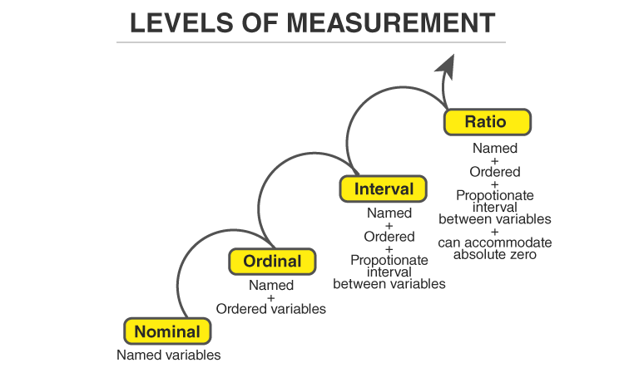

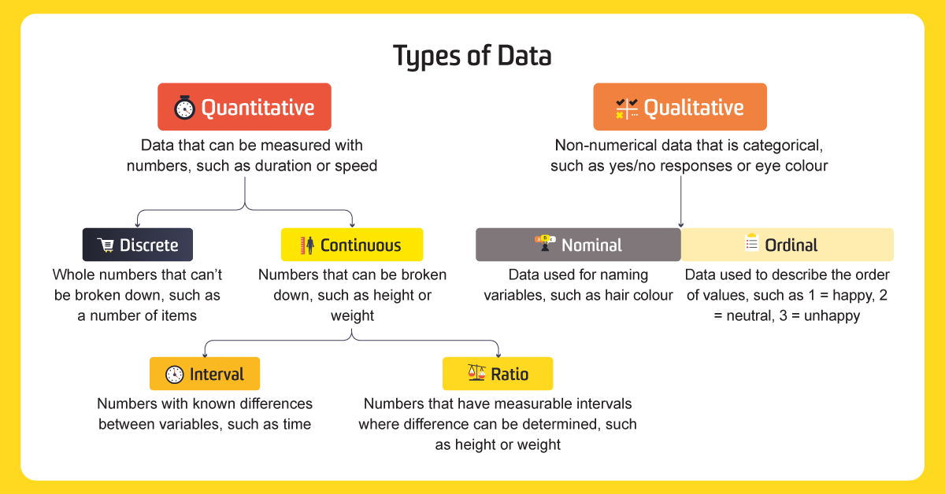

### **Nominal Scale**

A nominal scale is the 1stlevel of measurement scale in which the numbers serve as “tags” or “labels” to classify or identify the objects.

**Example:**

An example of a nominal scale measurement is given below:

What is your gender?

M- Male

F- Female

Here, the variables are used as tags, and the answer to this question should be either M or F.

### **Ordinal Scale**

The ordinal scale is the 2nd level of measurement that reports the ordering and ranking of data without establishing the degree of variation between them. Ordinal represents the “order.” Ordinal data is known as qualitative data or categorical data. It can be grouped, named and also ranked.

**Example:**

* Ranking of school students – 1st, 2nd, 3rd, etc.
* Ratings in restaurants
* Evaluating the frequency of occurrences
  + Very often
  + Often
  + Not often
  + Not at all
* Assessing the degree of agreement
  + Totally agree
  + Agree
  + Neutral
  + Disagree
  + Totally disagree

### **Interval Scale**

The interval scale is the 3rd level of measurement scale. It is defined as a quantitative measurement scale in which the difference between the two variables is meaningful. In other words, the variables are measured in an exact manner, not as in a relative way in which the presence of zero is arbitrary.

**Example:**

* Likert Scale
* Net Promoter Score (NPS)
* Bipolar Matrix Table

### **Ratio Scale**

The ratio scale is the 4th level of measurement scale, which is quantitative. It is a type of variable measurement scale. It allows researchers to compare the differences or intervals. The ratio scale has a unique feature. It possesses the character of the origin or zero points.

**Example:**

An example of a ratio scale is:

What is your weight in Kgs?

* Less than 55 kgs
* 55 – 75 kgs
* 76 – 85 kgs
* 86 – 95 kgs
* More than 95 kgs